**CALENDAR PAGE**

1. **DONE?** Please make the calendar colors/formatting match the heading. Having difficulty with the color of the D&R and OTNLEF on the calendar. What are the chances of making D&R always populate in BLUE and OTNLEF always populate in YELLOW. OR give me a color scheme that works. I will do the packets in the same color.

**Research: A google calendar event (aka appointment) color is based on the Calendar color. Inside a Google Account, multiple Calendars can be enabled (displayed) and each Calendar has a different color. An event’s color is based on the Calendar color (see Holiday is blue and JMA Calendar is brown). There’s no control over the event color/formatting outside the color of the Calendar.**

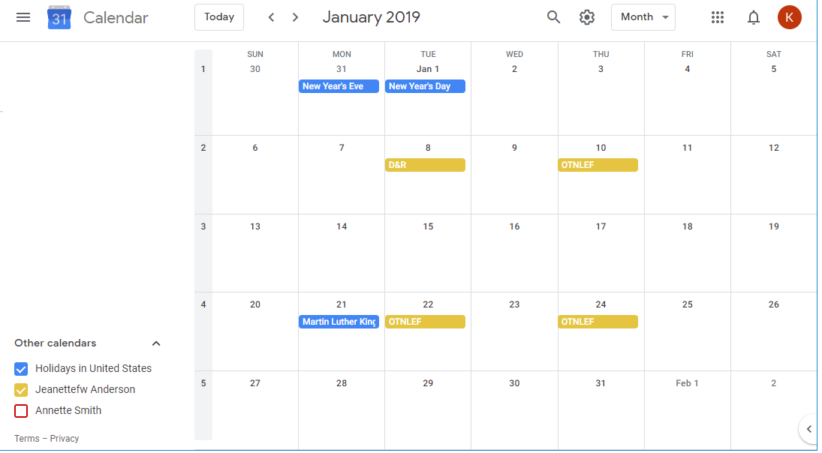

1. **DONE** I prefer military time and notice that time format changes from military to civilian entry on the site.

|  |  |
| --- | --- |
| OTNLEF  When              Thu, January 24, 2019, 8:00 am – 2:30 pm Changed the spacing  Description    Breakfast and registration start at 0745m  [Click here to register](https://www.google.com/url?q=https%3A%2F%2Fwww.jmanursingconsultant.com%2FJmancRegistrationForm.php%3Fotnlf%3D2019-01-24&sa=D&ust=1546271503445000&usg=AFQjCNG1KlKqng0_FVlBnAvJqvvn4QBmrQ)  [more details»](https://www.google.com/calendar/event?eid=XzhkOWxjZ3JmZHByNmFzamtjY3JqY2Nobjc0cWowZHI0YzlqM2lvaG5jOHIzZWNqNDZoaG04cDlrY2NyajhvYjQ2dGgwIGptYW5jY2FsZW5kYXJAbQ&ctz=America/Chicago)  [copy to my calendar»](https://calendar.google.com/calendar/event?action=TEMPLATE&hl=en&text=OTNLEF&dates=20190124T080000%2F20190124T143000&location&ctz=America%2FChicago&details=Breakfast%20and%20registration%20starts%20at%200745%3Cbr%20%2F%3E%3Cbr%20%2F%3E%3Ca%20href%3D%22https%3A%2F%2Fwww.google.com%2Furl%3Fq%3Dhttps%253A%252F%252Fwww.jmanursingconsultant.com%252FJmancRegistrationForm.php%253Fotnlf%253D2019-01-24%26amp%3Bsa%3DD%26amp%3Bust%3D1546271503445000%26amp%3Busg%3DAFQjCNG1KlKqng0_FVlBnAvJqvvn4QBmrQ%22%20target%3D%22_blank%22%3EClick%20here%20to%20register%3C%2Fa%3E) |  |

1. The Click here to register link does NOT take them customer to the new Registration Page.

This will be fixed on cut-over night because it currently is pointing to the production site (allowing customers to register).

1. **DONE** **SCHEDULE**:  Breakfast and registration begin at 0745 Hours. Class Hours are: 0800 Hours – 1430 Hours.
2. **CLASS DATES:** To register, scroll to the months/days and click on your chosen date, click “Click here to register”, then the Registration Form will appear.

Where’s the update here?

This will be fixed on cut-over night because it currently is pointing to the production site (allowing customers to register).

1. **DONE** DELETE THIS STATEMENT Please, do NOT complete Registration Form until ready to submit payment.
2. **DONE** Download [Outlook Calendar Content](https://calendar.google.com/calendar/ical/jmanccalendar%40gmail.com/public/basic.ics) – import into Outlook DOES THIS EXPOSE THE SITE TO HACKING, ETC?

 No WP will prevent that!

**REGISTRATION** **PAGE**

1. The new one, please replace the old on calendar dropdown registration form.

This will be fixed on cut-over night because it currently is pointing to the production site (allowing customers to register).

1. DONE The middle initial goes between the first and last name, please.
2. DONE NO Nursing License#, check the SN box and Enter your last four SSN# SN:  SSN:  [ Last 4 numbers only ] [? (hover over question mark)](http://creativedesignsandsomuchmorebymarcus.site/registration/)
3. The STATE dropdown does NOT work—stuck on TX.
4. DONE The CLASS DATE dropdown needs to display on the current (2019) dates. Please do NOT display the 2017 and 2018 dates.